Captain James Hope Painting
Institution Affiliation:
Students Name:

The Bloodiest Day-The Battle of Antietam Painting
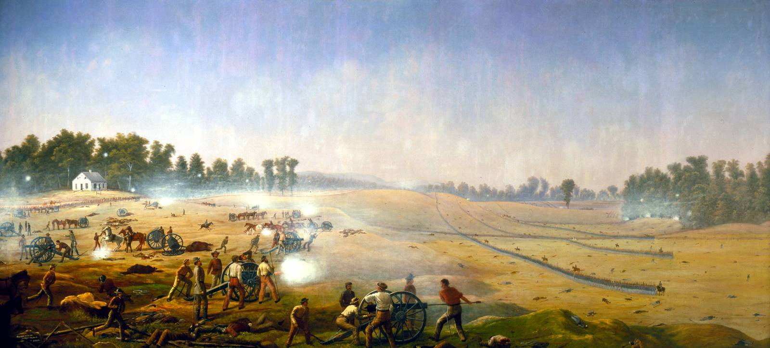
The painting was designed and painted by Captain James Hope in the 1800's. James Hope was a 43 years old professional artist who was a Union soldier of the Second Vermont Infantry. Before he was disabled by illness, James Hope was Antietam active part that involved plenty of engagements. Later on, his work was reduced to scouting and map making due to his minimum flexibility. As one of the paintings suggests, Hope was involved in sketching battles from observation. The purpose of painting this battle was to put on record since it was the deadliest battle in the history of Antietam. The audience was the Antietam community whose memories were recorded either in photographs or painting.
The painting expresses three brigades of Union troops proceeding under Allied fire. In the painting of Antietam, lifeless rebellious shooters lie next to the wreck of their battery. The building in the painting, Dunker church, was the scene of furious fighting. The painting was a representation of the pivotal battle of the Civil War between the Union from the South and Lee's army from the North. According to Civil War Talk (2012), in this battle over 22,720 men fell as casualties in a day, while others died later as they were receiving treatment. All summing up to 23,000 men. The battle is one of the bloodiest in the American history, was the main reason James Hope decided to paint the event.
The documentation here is painting with a clear purpose of recording a major and brutal event that would not go unnoticed in the American history. The documentation was done in five paintings expressing the battle at different stages. This mode of the recording was quite detailed and more vivid, unlike other means like letters that would need a lot of explanation at every stage of the battle. A definition of the painting dimensions was quite large although nothing specific is mentioned apart from their net weight of 200 pounds, (Civil War Talk, 2012).
Despite the detailed painting, James had a few assumptions that would have been easy for anyone to recognize the context without any background information. The painting was not as bloody as the actual battle. One would confuse it with normal battles of Antietam. The second assumption was the casualties in the painting did not showcase the massive nature of 22,730 soldiers who lost their lives.
The assumptions, however, does not make the context false. I strongly believe the information was true. Some of the supportive features of the painting are the background location, where one can see the Dunker Church (1852). The Church up to date has been tagged with the name "The Battlefield Church" in Sharpsburg, MD, USA, with a little modification sustaining the famous structure. The painter James Hope, being a professional artist, part of the battle scouts and map making, plays a role to the reliability of the source.

From the circumstances in the era of the Civil War, almost all communities involved shared similarities in their culture, social, political and economic practices. The culture of the North and the South was not that different. Often, the events of the day revolved around training young men, gathering food and making weapons. However, the North people had the upper hand of industrialization that made them superior in weapons, training, and productions. These factors made life in the South hard, especially economically. Mobilizing their resources in a slave outlawed land was not possible.
They also faced suppressive tactics from the North; hence their economy could not stand that of the Southerners. Politically, the two states were divided on statuses. The North was a strong financial and industrial center while the South had an agricultural economy. In 1860 the fate of the election fell under Abraham Lincoln who was against division of America. In the meantime, the South was under Lee’s influence who leads them to war with the South a year later. The division was settled when Lee's army surrendered to Lincoln, which marked the end of Civil War.
The importance of this paint goes beyond political difference during the 1800's. Today, the effects of the Civil War are still felt even today. Betsy Towner (2011) We now identify ourselves as either Democrats (Southerners) or Republicans (Northerners). On the other hand, the economic developments done by Abraham such as The First Transcontinental Railroad, Homesteading in the West and the Land-grant College System, prized America as a land of opportunities up to date. The era of the Civil War influenced mobile medics whom now we have finessed their profession into Hospitals and Ambulances.

The painting of James Hope means a lot to the Americans and their history. Betsy Towner (2011) explains at least 8 reasons why we should thank the Civil War. Personally, I view the portrait as a symbolic mark for the need to have peace and channel the strengths to solidarity and not division. There is basically no benefit in going into war over the political and economic difference.

Citations
Primary Source
Hope, James Painting on the Bloodiest Battle in Antietam.
Secondary Sources
Civil War Talk Website. (2012) Captain James Hope's Antietam Paintings. https://civilwartalk.com/threads/captain-james-hopes-antietam-paintings.74138/
Towner Betsy (2011) Article. How the Civil War Changed Your Life?
https://www.aarp.org/politics-society/history/info-04-2011/8-ways-civil-war-changed-lives.html

